DBSE &DBD

Name = K.Dheeraj
Roll no= 2520030193

QUERY 1:-
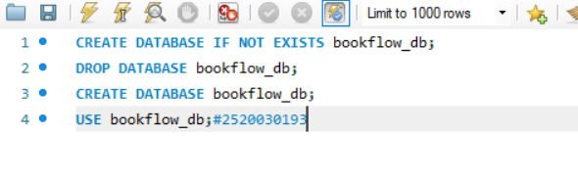
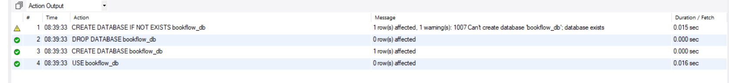

Query 2:-
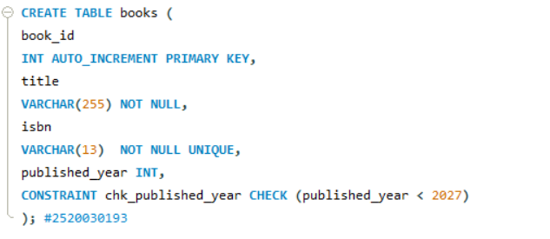
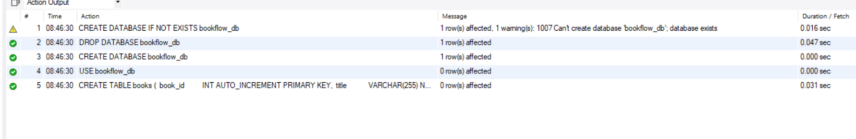

Query 3:-
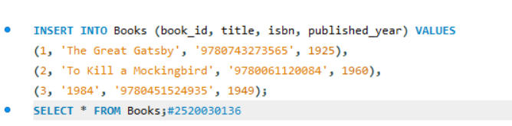
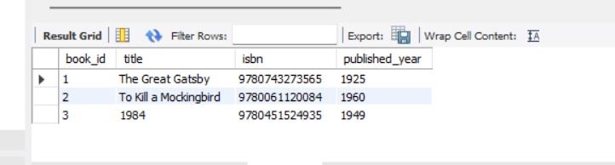

Query4:-
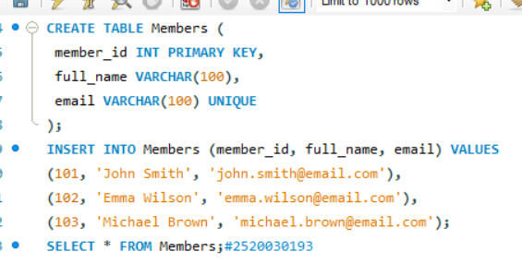

Query 5:-

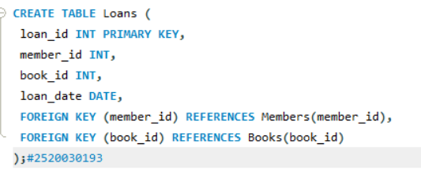

Query 6:-
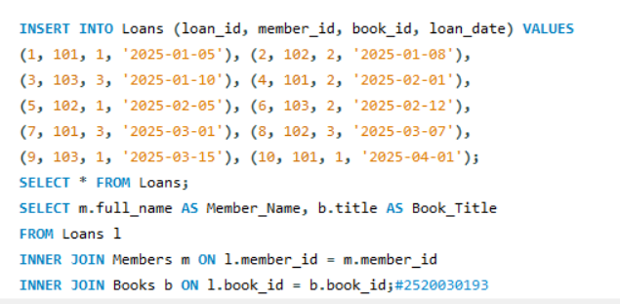

Query 7:-
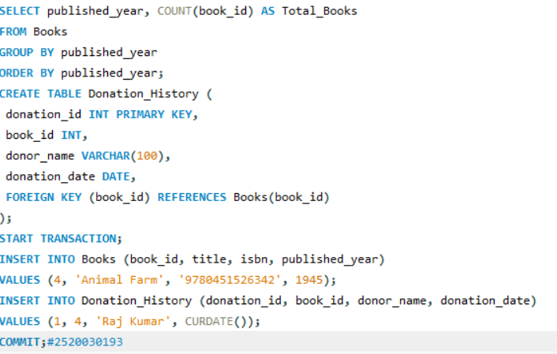

Query 8:-
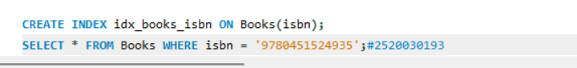

Books15
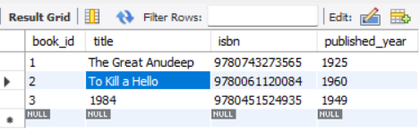

Members16
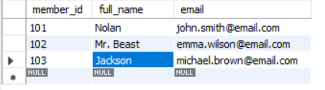

Loans17:
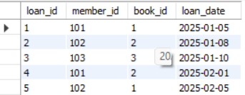

Result 18:
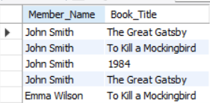

Result 19:
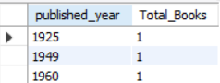

Books20:
